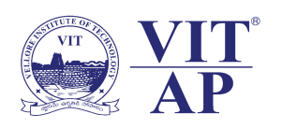
Student Welfare Office
Event Documentation
Field Visit- Chiguru Orphanage
Name of the Club: Open Community Rudra (NGO) Event No: 05
Date of the event: 23.02.2020 No of participants: 25
Name of the Faculty coordinator: Prof. S. Karthikeyan Email: karthikeyan.s@vitap.ac.in
Contact No: 9791306877 Faculty Area: 165, AB- 1

Event Description:
- “There is no higher religion than human service. To work for the common good is the greatest creed.” As a stepping stone to achieve the vision of a better world, the Open Community Rudra (NGO) organized a field visit to the Chiguru Children’s Village in Amravati on 23rd February, 2020 from 9:30 am to 3:00 pm as a part of Pre- VITopia event.
- The students, along with the faculty coordinators, interacted with the children by conducting games sessions, motivational speeches, mock drills, and fun competitions that created an environment filled with laughter and joy.
- The students served the lunch which was sponsored by the club to the children. In the end, the donations and gifts were distributed. The gifts given to them became the reason for their teeth revealing smiles and love filled hugs.

